Week 4 Assignment

Muhammad Sharif Miya
Westcliff University
PRG 200: Programming in the Cloud
Professor Pandey
July 24, 2026
Question number 1
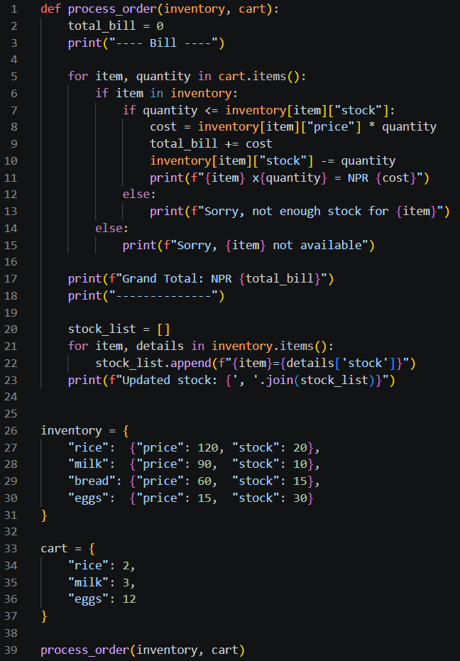

Output
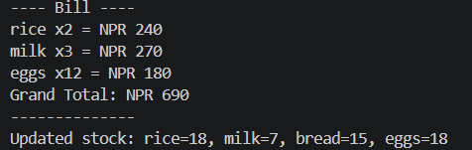
Question number 2
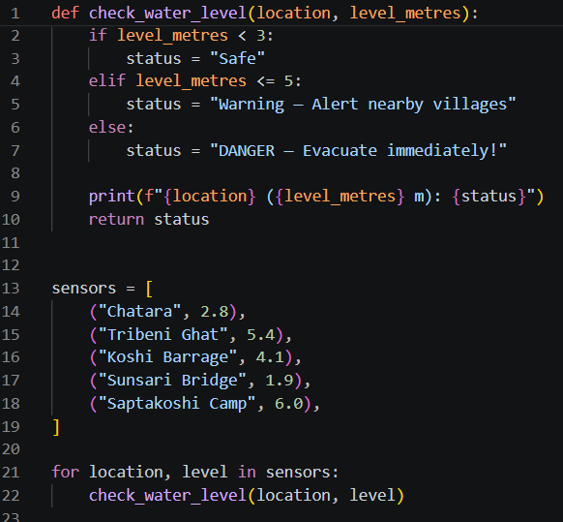
Output
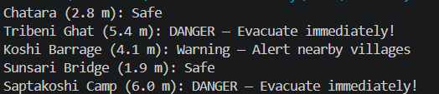

Question number 3
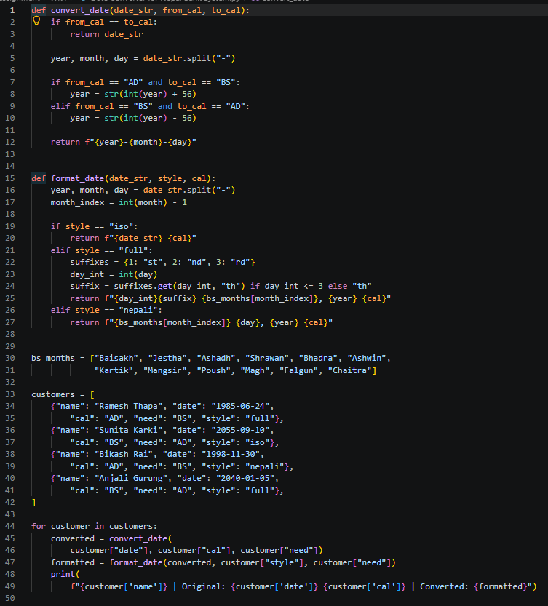

Output
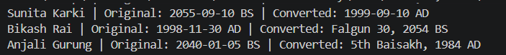
Question number 4
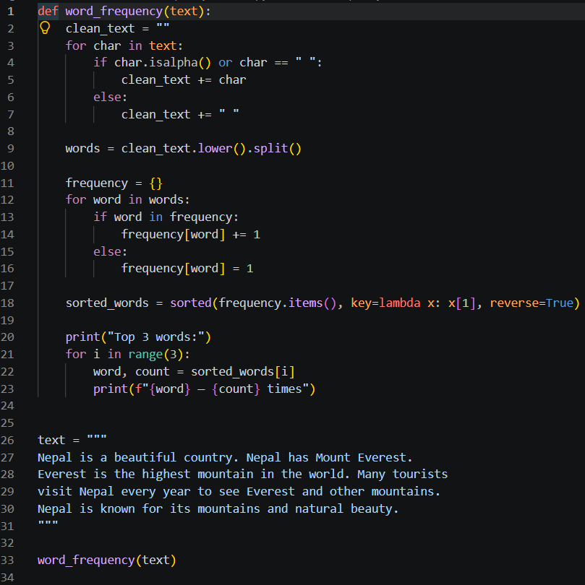

Output
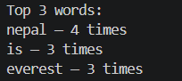

Question number 5
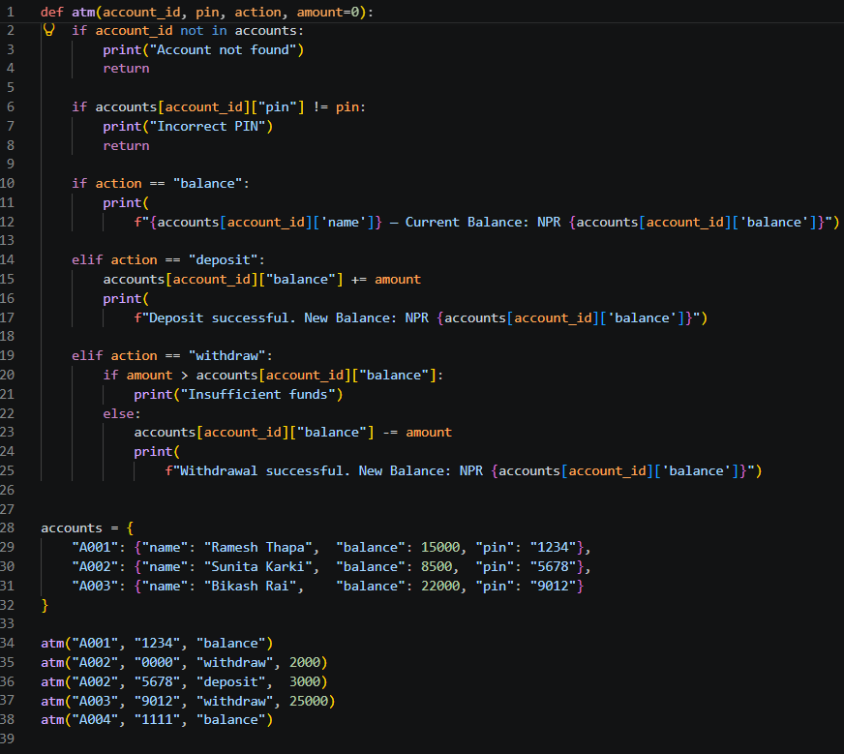
Output
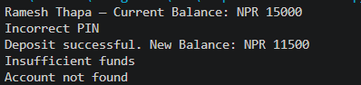

Github link-:
https://github.com/Sharif123098/Python_Logics.git

